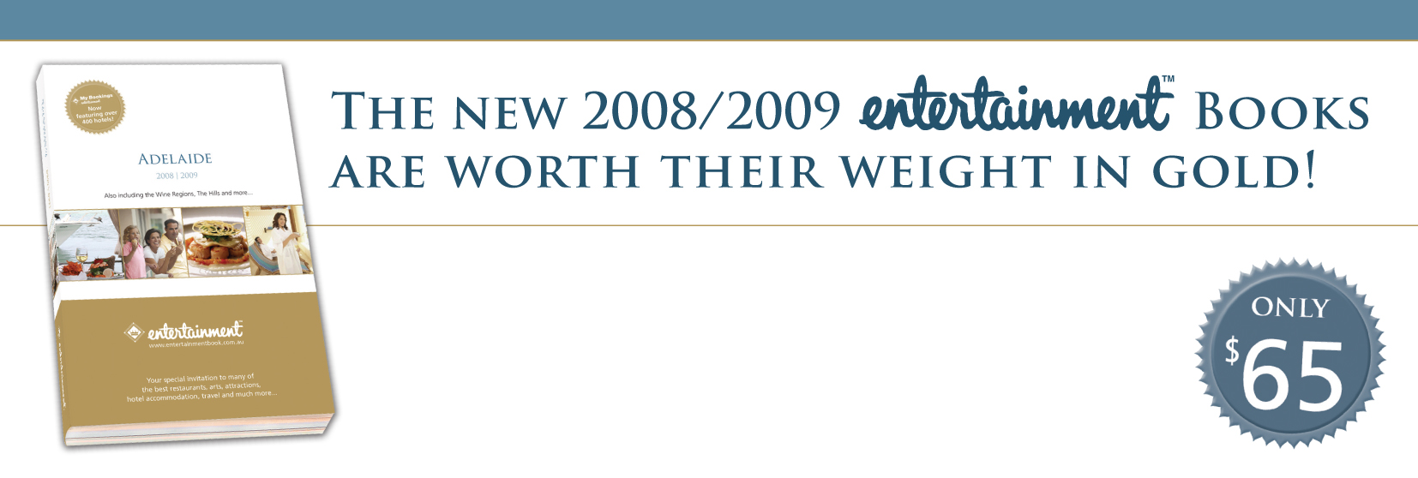  Purchase your brand new 2008/2009 Entertainment™ Book now to receive over $15,000 in valuable offers, valid through 1 June, 2009. At the same time, you’ll be helping community fund-raising!  The Entertainment™ Book is your guide to the best restaurants, hotel accommodation, attractions, sports and leisure activities... all with 25% to 50% off or 2-for-1 offers. Plus,  My Bookings™... Compare rates, check availability and book your accommodation online.  Here is a sample of the many well known businesses providing valuable offers in the new Adelaide Entertainment™ Book…  Fine and  Contemporary Dining  • The Melting Pot  • Regattas  • Jolleys Boathouse  • Stella  • Farina Kitchen and Bar  • Auge Ristorante  • The Grange  • Esca  • The Manse  • Zucca Greek Mezze  • Enoteca  • The Lion  • Magill Estate  • Eros Ouzeri  • The Greedy Goose  • Skillogalee  • Lido Ristorante  • Rigoni’s  • Salt  • Tandoori Oven  • The Sauce  • Beyond India  and many more... |  | Casual Restaurant  and Family Dining  • The Bombay Bicycle Club  • The Archer  • The Alma  • Café Paradiso  • Ramsgate Hotel  • Fellini Café  • T-Chow Chinese Restaurant  • Scuzzi  • Spargo’s  • The Store  • The Crown Hotel  • Seaford Hotel  • The Aldgate Pump  • The Norwood Hotel  • Buckingham Arms Hotel  • Danny’s Thai  • Café Mondiali  • Belgian Beer Café Oostende  • Montezuma’s  • Red Rock Noodle Bar  • The Strand  • Bocelli  and many more... |  | Informal Dining  and Takeaway  • McDonald’s  • Donut King  • Noodle Box  • New Zealand Natural  • Bean Bar  • Pizza Hut  • McCafé  • Hungry Jack’s  • Nando’s  • Domino’s  • Wok in a Box  • Wendy’s  • Oporto’s  • Cold Rock Ice Creamery  • Hudsons Coffee  • Red Rooster  • Pizza Haven  • Gloria Jean’s Coffees  • Brumby’s  • Red Rock Express  • Baskin Robbins  • Cherry Blossom  and many more... |  | Arts, Sports  and Attractions  • Wallis Theatres  • Kangaroo Island Sealink  • AMF Bowling Centres  • Hoyts Cinemas  • Adelaide Zoo  • Adelaide Aquatic Centre  • Adelaide Symphony Orchestra  • State Swim  • Greater Union  and many more...  Retail, Travel, Leisure  and Accommodation  • Hamilton Island  • BreakFree Hotels Resorts Apartments  • Golden Door Health Retreats  • Noosa Springs Resorts  • Avis/Budget/Europcar/Hertz/Thrifty  • Movie World, Sea World,  Wet’n’Wild Water World  • Fountain Cosmetics  • Gaz Man  and many more...
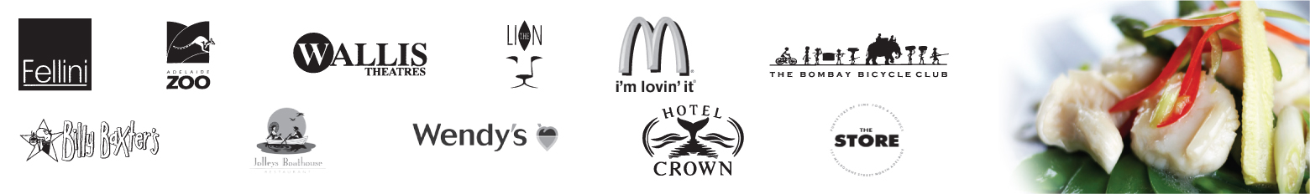

For a complete listing of participating businesses or more information about Entertainment™ Books for other cities, please visit www.entertainmentbook.com.au.
To purchase your new Entertainment™ Book from Enfield Harriers Athletics, contact

Darren Billett
enfield.harriers@gmail.com

Limited Offer!!! Order & pay for your Book before March 27th 2008 and receive 6 bonus offers for restaurants brand new
to our 2008/2009 Entertainment™ Book, worth over $160, that you can use straight away!

20% of the proceeds from every Book sold will benefit our fundraising, Thank you!
ORDER FORM  I will collect the Book from you OR  I have included $7 per Book for postage and handling

Name: ______________________________________________________ Phone: ______________________

Address: _________________________________________________________________________________
Method of payment: Cheque  Cash  Money Order

Number of Adelaide Books purchased: _____ x $65 (GST included) = ______ = Total enclosed (+ $7 P&H) $ ________

Entertainment™ Books are in limited supply. Orders are filled on a first come, first served basis.
Note: Payments should be made to the organisation listed above. If you have additional questions, you may call the Entertainment™ office on (08) 8364 6115.

